

From the heart of . . .

This is a favorite time of year for me. It always brings back memories of family gatherings with lots of laughter and love. My parents made the holidays very special. Mom baked for weeks ahead; there were cookies of every imaginable shape and flavor, divinity and fudge and of course the much-loved Christmas morning coffee cake. The tree had a mountain of gifts and the house was always beautifully decorated. Mom had a special set of Lenox porcelain. It consisted of 4 pieces each shaped in a different letter spelling the word N-O-E-L and had beautiful holly painted on each piece. It was always displayed on the mantel with greenery and small red bulbs scattered here and there. I can’t remember a Christmas that it wasn’t there.
Table of Contents
A Bible Study | Page 2
A Beautiful Story | Page 6
Beauty Tips | Page 3
Book Review | Page 3
Breakfast At McDonalds | Page 7
Coffee & Tea Tips | Page 3
Craft Corner | Page 5
Devotional | Page 5
Editor Contact Information | Page 8
Oh to be ten again | Page 2
Prayer for the Pastor | Page 6
Public Access TV Information | Page 4
Salvation Message | Page 4
Where Do I Find It In The Bible | Page 7

I come from a rather large family with 3 brothers and 2 sisters. I’m the youngest girl and I have 1 older brother. I grew up in the mid-west, Iowa to be precise. I still remember so many Christmases but one in particular stands out in my mind. It was a Christmas when most of us had grown and moved away but we all made it home that year.

I must have been 20 or 21 and was living in Denver, CO. at the time. My youngest brother was still at home. Everyone else had moved away, married and had their own families. When we all arrived there were 22 of us under the same roof for three or four days. There was always room though. It could get a little hectic what with babies and toddlers and the always-present family dog and cat to contend with. This particular Christmas was exceptionally cold so the kids didn’t get outside to play. Needless to say, they got a little rambunctious at times. One particular time they were in the living room and something was thrown and as it careened across the room everyone held their breath because it was heading straight for the N-O-E-L. There was stunned silence as the object crashed into the mantel and shattered Mom’s treasure. No one

Volume 2: Issue 4 – Winter 2007

said a word. Mom broke the silence as a muffled tearful “I’m sorry” came out of someone’s mouth.

Without a cross look, Mom said something about it only being a decoration and that no one was hurt and it was ok. She then went and got the dustpan and broom and scooped it all into a brown paper bag and took it to the garage and put it in the trash. The rest of the day was fairly quiet; no more roughhousing went on.

That evening when we went to bed we all told Mom how sorry we were about the N-O-E-L because we knew how much she
treasured it. The next morning, to our astonishment…
Continued on page 7

Upcoming Events

- Women of Faith Bible Study at Life Church* -1st & 3rd Fridays, 9:30 a.m. (No Study on Dec. 21st)
- Women's Monthly Meeting at Life Church* -4th Friday, 7:00 p.m.

- Sunday, December 16th – Christmas Dinner (following Sunday service)
- Monday, Dec. 31st – New Year’s Eve Service
- Sunday, Jan. 5th, 10:00 a.m. – Friends & Family Day (Soul Food Sunday)
- Sunday, Feb. 3rd, 10:00 a.m. – Friends & Family Day
- February, 2008, Valentine’s Dinner – Date & Time TBA
- March 9th – Daylight Savings Time- Remember to set your clocks ahead.
* = call or e-mail Judy for details 860-482-8651 or jjwrite@sbcglobal.net
A Mini - Bible Study
By Judy Johnson
This time of the year we sing the song, “Joy to the World”. Other times we sing, “I’ve got that Joy Joy Joy Joy down in my soul”. But what is joy and where does it come from?
Are you happy today? Do you ever get sad or depressed? The statistics are staggering; though we are the most prosperous country in the world, with the most freedoms and opportunities, we spent over $43 billion dollars last year on counseling, psychologists, psychiatrists and drugs to treat depression. That should tell us it’s not about where we live, how much money we have, it’s not about our “stuff”, and not even the opportunities that are available to us, it’s something much deeper.
First of all, let’s see what joy is not. Joy is not laughter and pleasure, though joy has both laughter and pleasure. Read Proverbs 14:13, “Even in laughter the heart is sorrowful; and the end of that mirth is heaviness.” We so often hide behind laughter and jokes, but this scripture is telling us that it leads to a heavy heart (burdens). And Joy is not happiness because happiness comes and goes with circumstances, things, activities, even the weather.
So what is Joy? It’s a sense of well-being that comes from God, a contentment, a product of the Holy Spirit, a fruit of the Spirit. Read Galatians 5:22, “But the fruit of the Spirit is love, joy, peace, longsuffering, gentleness, goodness, faith,” It’s a fruit, a result of having God’s Spirit residing in you. And Philippians 4:11 says, “Not that I speak in respect of want: for I have learned, in whatsoever state I am, therewith to be content.” It’s a choice we make. Do we see our glass half full or half empty? Do we see each situation as a problem or an opportunity?
How do you get joy? Read Psalms 16:11, “Thou wilt show me the path of life: in thy presence is fullness of joy; at thy right hand there are pleasures for evermore.” It comes from being in God’s presence, spending time with God, time alone in prayer and meditation and time with the family of God in praise, worship and hearing the Word, in fellowship.
Romans 14:17 says, “For the kingdom of God is not meat and drink; but righteousness, and peace, and joy in the Holy Ghost” It’s not about things; it’s about the desires of your heart.
Where does joy come from? There are lots of scriptures that tells us this; here are just a few: Jude 1:24 says, “exceeding joy comes from God”; 1 Peter 4:13 says, “glad with exceeding joy”, 1 Peter 1:8 says, “yet believing, ye rejoice with joy unspeakable…”. Joy comes from the Lord!
Read Romans 15:13, “Now the God of hope fill you with all joy and peace in believing, that ye may abound in hope, through the power of the Holy Ghost.” Without the Holy Ghost in our lives, the joy we display is a façade. To have the true joy, the “unspeakable” joy, you must have the Holy Ghost operating in and through you.
Read Acts 2:46; Acts 16:34; and 1 Thessalonians 1:6 – What happened here? They were called, they heard, they believed and received the gospel. They repented, were forgiven, were baptized and received the spirit – they reacted with Joy.
So, how do you live that way, today? Read Ephesians 5:15-20, meditate on it. Allow God to show you those areas of your life that rob you of your joy and release them to him. See also John 16:20-24; 15:11 and 1 John 1. When you’re working for Christ, when you’re serving Him as He has called you to do, your joy will be FULL.
Read Psalms 16:11 again. Why is David saying this? – look back at verses 8, 9 & 10 “I have set the LORD always before me: because he is at my right hand, I shall not be moved. Therefore my heart is glad, and my glory rejoices: my flesh also shall rest in hope. For thou will not leave my soul in hell; neither will thou suffer thine Holy One to see corruption.”
There’s an assurance that comes with knowing Jesus Christ as our personal Savior. To recognize His voice, to spend time with Him and to obey; that’s where our joy comes from and that’s when it will remain.

Oh To Be Ten Again
(Author Unknown)
A man asked his wife, “What would you most like for your birthday?” She said, “I’d love to be ten again.” On the morning of her birthday, he got her up bright and early and off they went to a theme park. He put her on every ride in the park—the Death Slide, The Screaming Loop, the Wall of Fear. Everything there was; she had a go. She staggered out of the theme park five hours later, her head reeling and her stomach upside down. Into McDonald’s they went, where she was given a Double Big Mac with extra fries and a strawberry shake. Then off to a theater to see Star Wars – more burgers, popcorn, cola and sweets.
At last she staggered home with her husband and collapsed into bed. Her husband leaned over and asked, “Well, dear, what was it like being ten again?”
One eye opened and she groaned, “Actually I meant a dress size.”
Book Review
By Donna Rae Dubois

Hinds’ Feet on High Places
By Hannah Hurnard

Hinds’ Feet on High Places is one of Hannah Hurnard’s best known and best loved books. This book is a beautiful allegory dramatizing the yearning of God’s children to be led to new heights of love, joy, and victory. Follow Much-Afraid on her spiritual journey through difficult places with her two companions, Sorrow and Suffering. Learn how Much-Afraid overcomes her tormenting fears as she passes through many dangers and mounts at last to the High Places. There she gains a new name and returns to her valley of service, transformed by her union with the loving Shepherd.

I first started reading this book years ago. I put it down thinking it was like a fairy tale and I just couldn’t get into it. Now, 10 years later, I’ve picked it up again, but this time I was unable to put it down. The Holy Spirit can speak to you through this book. If your walk with the Lord has been filled with doubt and fear around every corner, and you are struggling with trusting Jesus as your loving and guiding shepherd, this is a must read for you! It is filled with Biblical truths, especially from the Song of Solomon. I know I’ll be reading it over again and again. I believe it’s especially timely for Life Church. We have been set apart and we are called by HIS name. Praise the Lord!

Beauty Tips By Gemma Paul

Moisturizing – It’s winter and it’s time to moisturize, moisturize, moisturize!!!

Moisturizing is a very important step that helps your foundation go on more smoothly and evenly. Always begin with a freshly washed face, and then apply moisturizer. It works best with a damp face. It evens the skin's porosity and is most effective when it’s left to absorb for a few minutes before applying your makeup. You can use a tinted moisturizer or a heavier one, just be sure to choose the right one for your particular skin type.

Moisturizers for normal skin are usually light to help even out any dry areas.

Moisturizers for sensitive skin are fragrance and irritant free.

Moisturizers for oily skin are extremely light and won't clog pores. Many have oil absorbing properties in them that actually help control the oil. Oily skin needs moisturizer because often, it can be over-dried by cleansers. Our body is so smart that it actually produces more oil to compensate for the over-dryness which only makes the complexion appear greasier. A light moisturizer keeps oily skin from producing more oil and can help even out its porosity.

Coffee & Tea Tips
- To preserve maximum flavor, store fresh ground or whole bean coffee in an airtight container in the refrigerator for up to 2 weeks.
- Long-term storage is best done in the freezer for up to 1 year.
- Unopened vacuum-packed cans or packages of beans or ground coffee can be stored in the pantry for up to 1 year.
- For the best-tasting coffee, always start with a clean coffee maker that has been washed with soapy hot water, and brew coffee with fresh cold water.
- You can store tea bags or loose tea at room temperature in an airtight container for up to 2 years. Be sure to keep each kind or flavor of tea in separate storage containers.
- To make the perfect cup of tea, pour boiling water over one tea bag or a tea infuser containing 1 teaspoon of loose tea. Allow to steep for 3-5 minutes or until the desired strength has been reached. Remove the bag or infuser.
Easy Cutting for Cinnamon Rolls
- If you find it difficult to slice cinnamon roll dough with a knife, try this tip. Place a piece of dental floss or heavy-duty thread under the rolled dough, 1 inch from the end. Bring the sides of the thread or floss up around the dough and cross it over at the top, cutting through the dough and filling. Repeat every inch.

Have you come to the end of your rope and don’t have anything left to hang on to? Hang on to Jesus. He will never let you down.

American Standard 1917 Edition
JOHN 3:16 “For God so loved the world, that he gave his only begotten Son, that whosoever believeth in him should not perish, but have everlasting life.”
JOHN 3:17 “For God sent not his Son into the world to condemn the world; but that the world through him might be saved.”
JOHN 3:18 “He that believeth on him is not condemned: but he that believeth not is condemned already, because he hath not believed in the name of the only begotten Son of God.”

Accept Jesus into your heart right now. You will never regret it. It is very simple to do. Just say this prayer: “Father, in the name of Jesus, I come to you and I ask you to forgive me of all my sins. I ask Jesus into my heart right now. You said that if I believe in you I would not perish but have eternal life. I believe that and I thank you Jesus for setting me free. I give my life to you Jesus and I say that not only are you my Savior but now you are my Lord. Thank you for loving me. Amen”

Join Life Church on Public Access TV
(Check your local cable company for day and time)
Cox Communications – Channel 15
Serving: Enfield, East Windsor, East Granby, Glastonbury, Granby, Hartland, Manchester, Newington, Rocky Hill, Somers, South Windsor, Suffield, Union, Stafford Springs, Wethersfield, Windsor Locks & Holland, MA

Comcast – Channel 5
Serving: Simsbury & Windsor

Nutmeg TV – Channel 5
Serving: Avon, Berlin, Bristol, Burlington, Canton, Farmington, New Britain & Plainville

Cablevision of Litchfield – Channel 5
Serving: Bantam, Cornwall, Goshen, Litchfield, Morris, Northfield, Oakville, Thomaston, Torrington, Warren & Watertown

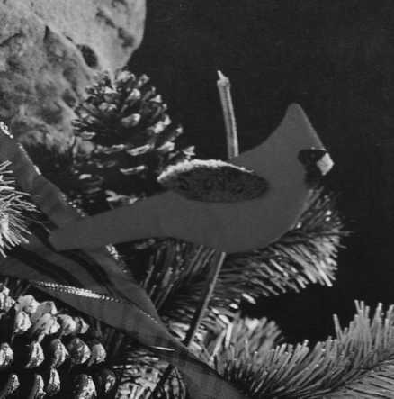
Craft Corner
By Karen Cobleigh
Christmas Cardinals
You will need fabrics for body, beak, mask, and wing; red felt for backing; low-loft polyester bonded batting; Delta™ Decorative Snow (available in paint section of craft stores); paintbrush; lightweight cardboard; tracing paper; small twig; and a low-temperature hot glue gun and glue sticks.
1. Trace body, beak, mask, and wing patterns, separately onto tracing paper; cut out. (See below, you may want to enlarge slightly)
2. Use body pattern to cut 1 shape each from cardboard, batting, and felt. Glue batting shape to 1 side (front) of cardboard shape. Place cardboard shape batting side down on wrong side of fabric. Trim fabric to approximately ½” from cardboard shape; make clips in edge of fabric at approximately ¼” intervals to 1/16” from cardboard shape. Alternating sides and pulling fabric taut, glue clipped edges of fabric to back of cardboard shape. Glue felt shape to back of cardboard shape.
3. Use wing pattern and repeat Step 2.
4. Reversing patterns as necessary use beak and mask patterns to cut shapes from fabrics.
5. Use small dots of glue to glue beak, mask, and wing to body.
6. Use paintbrush to paint decorative snow along edge of wing; allow to dry.
7. Glue twig to back of bird.
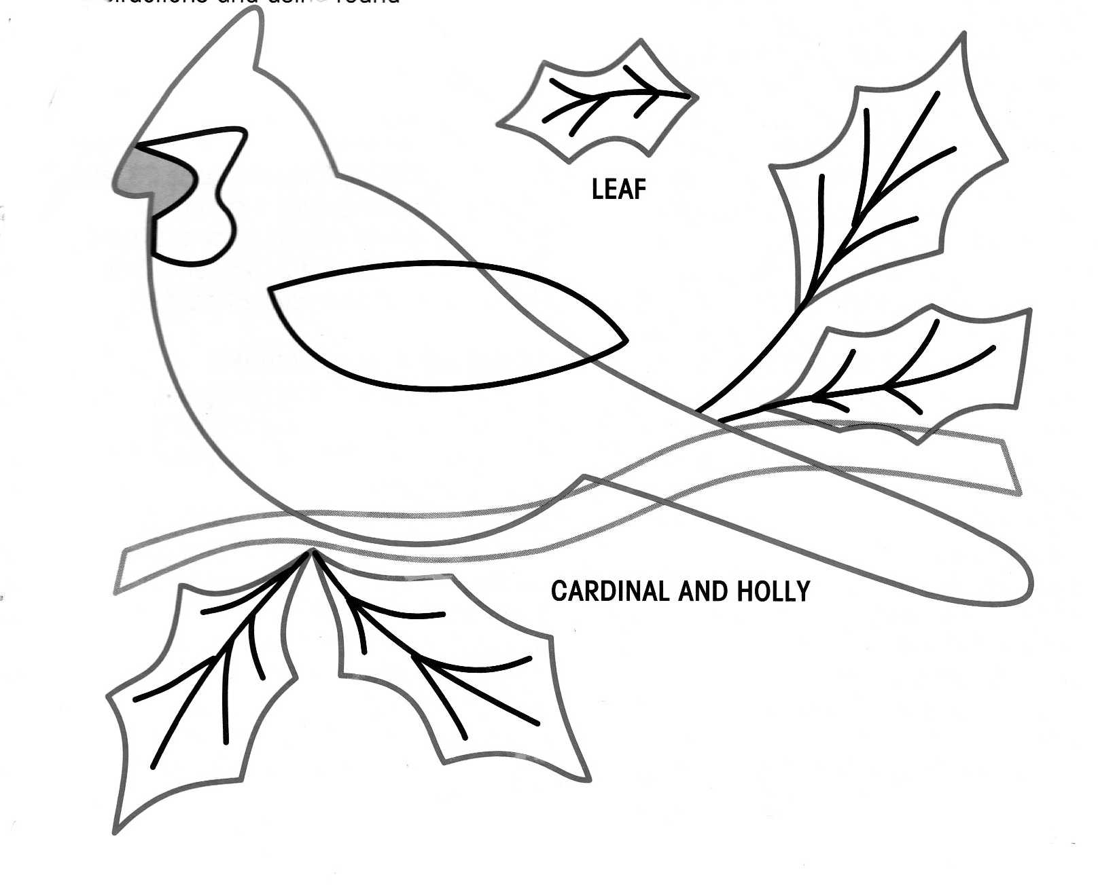
evotional by Judy Johnson

The Greatest Gift

There’s a beautiful song entitled, Mary Did You Know. The songwriter is speaking to Mary’s heart, asking if she realized the awesomeness of the power that she was carrying. He asks if she knew that the child she carried would someday: walk on water, calm an angry storm, heal the sick, and restore sight to the blind… He asks if she knew that the child she would deliver would actually deliver her! And the part of the song I like the best is, “when you kiss your little babe, you’ve kissed the face of God”.
Mary was carrying the Great I Am; the Savior of the world had been entrusted to her. The Bible says in Luke 1:30-33, “…Fear not, Mary: for thou hast found favour with God. And, behold, thou shalt conceive in thy womb, and bring forth a son, and shalt call his name JESUS. He shall be great, and shall be called the Son of the Highest: and the Lord God shall give unto him the throne of his father David: And he shall reign over the house of Jacob for ever; and of his kingdom there shall be no end.”
We are part of that kingdom today. Each one of us who has called upon the Name of the Lord is now carrying Jesus within us. We have been entrusted with this treasure and we're not to keep it to ourselves. 2 Corinthians 4:5-7 says, “For we preach not ourselves, but Christ Jesus the Lord; … For God, who commanded the light to shine out of darkness, hath shined in our hearts, to give the light of the knowledge of the glory of God in the face of Jesus Christ. But we have this treasure in earthen vessels that the excellency of the power may be of God, and not of us.” What better gift to give this Christmas than the gift of eternal life?
Ephesians 2:8 says, “For by grace are ye saved through faith; and that not of yourselves: it is the gift of God.” And Romans 6:22-23, “but the gift of God is eternal life through Jesus Christ our Lord.” It’s the perfect gift; give it with Joy this Christmas and always. God bless you.

Prayer for the Pastor

The Pastor’s Personal Life

“Stand …having put on the breastplate of righteousness.” Ephesians 6:14

Intercede: for his spouse, children and families: Psalm 91: 9-12 and Psalm 37:25
Cancel: in Jesus’ name all assignments against him: Matthew 16:19
Remove: by faith all obstacles to their total health and prosperity: Mark 11:23 and Philippians 4:19

A Beautiful story....makes you understand that things happen for a reason.
The brand new pastor and his wife, newly assigned
to their first ministry, to reopen a church in suburban Brooklyn, arrived in early October. Excited about their opportunities when they saw their church, it was very run down and needed much work. They set a goal to have everything done in time to have their first service
on Christmas Eve. They worked hard, repairing pews, plastering walls, painting, etc, and on December 18
were ahead of schedule and just about finished. On December 19 a terrible tempest - a driving rainstorm hit the area and lasted for two days. On the 21st, the pastor went over to the church. His heart sank when he saw that the roof had leaked, causing a large area of plaster about 20 feet by 8 feet to fall off the front wall of the sanctuary just behind the pulpit, beginning about
head high. The pastor cleaned up the mess on the floor, and not knowing what else to do but postpone
the Christmas Eve service, headed home. On the way he noticed that a local business was having a flea market type sale for charity so he stopped in. One of the items was a beautiful, handmade, ivory colored, crocheted tablecloth with exquisite work, fine colors and a Cross embroidered right in the center. It was just the right size to cover up the hole in the front wall. He bought it and headed back to the church. By this time it had started to snow. An older woman running from the opposite direction was trying to catch the bus. She missed it. The pastor invited her to wait in the warm church for the next bus 45 minutes later. She sat in a pew and paid no attention to the pastor. While he got a ladder, hangers, etc., to put up the tablecloth as a wall tapestry. The pastor could hardly believe how beautiful it looked and it covered up the entire problem area. Then he noticed the woman walking down the center aisle. Her face was like a sheet. 'Pastor,' she asked, 'Where did you get that tablecloth?' The pastor explained. The woman asked him to check the lower right corner to see if the initials, EBG were crocheted into it there. They were. These were the initials of the woman, and she had made this tablecloth 35 years before, in Austria. The woman could hardly believe it as the pastor told how he had just gotten the tablecloth.

The woman explained that before the war she and her husband were well-to-do people in Austria. When the Nazis came, she was forced to leave. Her husband was going to follow her the next week. He was captured, sent to prison and never saw her husband or her home again. The pastor wanted to give her the tablecloth; but she made the pastor keep it for the church. The pastor insisted on driving her home, which was the least he could do. She lived on the other side of Staten Island and was only in Brooklyn for the day for a housecleaning job. What a wonderful service they had on Christmas Eve. The church was almost full. The music and the Spirit were great. At the end of the service, the Pastor and his wife greeted everyone at the door and many said that they would return.
One older man, whom the pastor recognized from the neighborhood continued to sit in one of the pews and stare, and the pastor wondered why he wasn't leaving.
T he man asked him where he got the tablecloth on
the front wall because it was identical to one that his wife had made years ago when they lived in Austria before the war and how could there be two tablecloths so much alike. He told the pastor how the Nazis came, how he forced his wife to flee for her safety and he was supposed to follow her, but he was arrested and put in a prison. He never saw his wife or his home again all the 35 years in between. The pastor asked him if he would allow him to take him for a little ride. They drove to Staten Island and to the same house where the pastor had taken the woman three days earlier. He helped the man climb the three flights of stairs to the woman's apartment, knocked on the door and he saw the greatest Christmas reunion he could ever imagine.
Who says God does not work in mysterious ways?

Where Do I Find It In The Bible?
Miracles and Healings of Jesus
Jesus Turns Water into Wine | John 2:1-11
Jesus Feeds Many People | Matthew 14:13-21; Mark 6:30-44; Luke 9:10-17; John 6:1-15; Matthew 15:32-39; Mark 8:1-10
Jesus Calms a Storm | Matthew 8:23-27;Mark 4:35-41; Luke 8:22-25
The Great Catch of Fish | Luke 5:1-11
Jesus Walks on Water | Matthew 14:22-33; Mark 6:45-52; John 6:16-21
Jesus Heals People with Skin Diseases | Matthew 8:1-4; Mark 1:40-45; Luke 5:12-16; Luke 17:11-19
Jesus Casts Out Demons | Matthew 8:28–34; Mark 5:1-20; Luke 8:26-39; Matthew 12: 22-32; Mark 3:20-30; Luke 11:14-23; Matthew 17:14-20; Mark 9:14-29; Luke 9:37-43; Mark 1:21-28; Luke 4:31-37

Breakfast at McDonald’s
(Author Unknown)
This is a good story and is true.
I am a mother of three (ages 14, 12, 3) and have recently completed my college degree. The last class I had to take was Sociology. The teacher was absolutely inspiring with the qualities that I wish every human being had been graced with. Her last project of the term was called, "Smile." The class was asked to go out and smile at three people and document their reactions. I am a very friendly person and always smile at everyone and say hello anyway. So, I thought this would be a piece of cake, literally. Soon after we were assigned the project, my husband, youngest son, and I went out to McDonald's one crisp March morning. It was just our way of sharing special playtime with our son. We were standing in line, waiting to be served, when all of a sudden everyone around us began to back away, and then even my husband did. I did not move an inch... an overwhelming feeling of panic welled up inside of me as I turned to see why they had moved. As I turned around I smelled a horrible "dirty body" smell, and there standing behind me were two poor homeless men. As I looked down at the short gentleman, close to me, he was "smiling". His beautiful sky blue eyes were full of God's Light as he searched for acceptance. He said, "Good day" as he counted the few coins he had been clutching. The second man fumbled with his hands as he stood behind his friend. I realized the second man was mentally challenged and the blue-eyed gentleman was his salvation. I held my tears as I stood there with them. The young lady at the counter asked him what they wanted. He said, "Coffee is all Miss" because that was all they could afford. (If they wanted to sit in the restaurant and warm up, they had to buy something. He just wanted to be warm). Then I really felt it - the compulsion was so great I almost reached out and embraced the little man with the blue eyes. That is when I noticed all eyes in the restaurant were set on me, judging my every action.
I smiled and asked the young lady behind the counter to give me two more breakfast meals on a separate tray. I then walked around the corner to the table that the men had chosen as a resting spot. I put the tray on the table and laid my hand on the blue-eyed gentle -man's cold hand. He looked up at me, with tears in his eyes, and said, "Thank you." I leaned over, began to pat his hand and said, "I did not do this for you. God is here working through me to give you hope." I started to cry as I walked away to join my husband and son. When I sat down my husband smiled at me and said, "That is why God gave you to me, Honey, to give me hope." We held hands for a moment and at that time, we knew that only because of the Grace that we had been given were we able to give. We are not church goers, but we are believers. That day showed me the pure Light of God's sweet love. I returned to college, on the last evening of class, with this story in hand. I turned in "my project" and the instructor read it. Then she looked up at me and said, "Can I share this?" I slowly nodded as she got the attention of the class. She began to read and that is when I knew that we as human beings and being part of God share this need to heal people and to be healed. In my own way I had touched the people at McDonald's, my son, instructor, and every soul that shared the classroom on the last night I spent as a college student. I graduated with one of the biggest lessons I would ever learn:
UNCONDITIONAL ACCEPTANCE.

From the Heart of…Continued from page 1
…there was the N-O-E-L in its rightful place on the mantel. Mom had stayed up all night, gluing it back together. You see it was very special to her.
As we celebrate this season of Christmas let us never forget the treasure that we are to Jesus. No matter how battered and broken you may feel; Jesus can put the pieces back together. He can make something beautiful out of your life.

“The Spirit of the Lord GOD is upon me; because the LORD hath anointed me to preach good tidings unto the meek; he hath sent me to bind up the brokenhearted, to proclaim liberty to the captives, and the opening of the prison to them that are bound; To proclaim the acceptable year of the LORD, and the day of vengeance of our God; to comfort all that mourn; To appoint unto them that mourn in Zion, to give unto them beauty for ashes, the oil of joy for mourning, the garment of praise for the spirit of heaviness; that they might be called trees of righteousness, the planting of the LORD, that he might be glorified.” Isaiah 61:1-3
Have a Blessed Christmas,
Judy
“He gives snow like wool: he scatters the hoarfrost like ashes.
He casts forth his ice like morsels: who can stand before his cold?
He sends out his word, and melts them:
He causes his wind to blow, and the waters flow.”
Psalm 147:16-18

f you have any comments, questions, or additions to this newsletter, contact the Editor.
Jean Redekas
JRedekas@comcast.net
860-670-3194




“He giveth snow like wool: he scatters the hoarfrost like ashes.
He casts forth his ice like morsels: who can stand before his cold?
He sends out his word, and melts them: he causes his wind to blow, and the waters flow.

Picture by Jean Redekas

Photograph by Jean Redekas

Life Church
23 Griffin Road
Granby, CT 06035
860-653-3308
www.GranbyLifeChurch.com

To:

Printed at Olivieri Quickprint Center, 17 Hartford Avenue, Granby, Connecticut 06035, (860) 653-6928, Fax (860) 653-3768, olivieriquickprint.com

