

We’ve had a fabulous Spring. Our annual Day of Beauty was again a great success. The topic this year was “The Beauty of Holiness” and our ladies – your Sisters in Christ – brought God’s Word with richness, beauty and depth. They truly allowed themselves to be used of God. We had a terrific group of vendors to pamper and encourage us. And the men of Life Church outdid themselves with a fabulous luncheon. If you didn’t make it this year, plan to attend next year, you will be blessed.
Table of Contents
A Bible Study | Page 2
Attitude is Everything | Page 6
Beauty Tips | Page 3
Book Review | Page 3
Craft Corner | Page 5
Devotional | Page 5
Editor Contact Information | Page 8
Humor is Contagious | Page 6
Prayer for the Pastor | Page 7
Psalm 23 – Explained | Page 3
Public Access TV Information | Page 4
Recipe Corner | Page 3
Salvation Message | Page 4
A Strong Woman | Page 7
Where Do I Find It In The Bible | Page 7
As I write to you Augusto Perez, a true Apostle of Christ, has just concluded a fabulous week-end with Life Church. Friday evening he met with the Intercessory Prayer Team then gave a challenging message to the Friday Night Youth Group (Christ 4 Life). Saturday found the Leadership team of Life Church receiving wise council and vital teaching to both encourage and challenge us to leave our “safety zone” and move into our “faith zone”. Sunday’s message brought many to the altar, people were healed, people were filled, we were again encouraged and challenged to take that step to a more committed life in Christ. God has incredible plans for Life Church and it’s a thrilling and wonderful thing to find yourself right in the middle of God’s will.
From the heart of . . .
In August we will again be preparing the lunch for the Youth Camp bus ride to Pennsylvania. Mark your calendar for Sunday, July 29th and join us downstairs at 1:00 for the “Sandwich Assembly Line”. Also, in August, we will be having our Women’s Night of Fellowship. It’s our night to gather together with women of like precious faith from surrounding churches. Enjoy a time of worship, hear a word of encouragement, and spend time establishing new relationships or renewing old ones. Mark your calendars for August 24th at 7:00 pm at Life Church, 23 Griffin Road, Granby. Plan to come out, bring some friends and enjoy a beautiful evening designed just for you. Someone came to me a few weeks ago and asked if we had a “Lost and

Volume 2: Issue 2 – Summer 2007

Found”. They had found a single knitting needle in the parking lot and being a crafter knew someone would be
looking for it. I thought for a second and said, “No, but give it to me and I’ll ask around and see if I can find out who it belongs to.” It got me thinking. Have you ever lost something of great value to you? I remember last winter losing my wallet. I had just been to the bank for cash for the week. Got home, unloaded the groceries and was putting things away when suddenly I realized my wallet was not in my purse. I tore the car apart, I retraced my steps, I couldn’t imagine where it could be. (I even looked in the freezing thinking I had put it away with the ice cream!) I was frantic. It reminds me of the woman who lost the piece of silver (Luke 15:8-10). She had other pieces of silver, but she’d lost one of them and desperately wanted to find it.
Continued on page 7

Upcoming Events

Women of Faith Bible Study at Life Church*

Women's Monthly Meeting at Life Church*
-4th Friday 7:00 p.m.

Youth Camp – July 30 – Aug. 3

Church Picnic – Sat., Sept. 8 at 11:30 a.m. (Tentative)

* = call or e-mail Judy for details 860-482-8651 or jjwrite@sbcglobal.net

A Bible Study
Greatest Love Story by Judy Johnson
Do you love “love” stories? Years ago my grandmother gave me her collection of Grace Livingston Hill books. They are:
- Beautifully wholesome,
- Full of examples of integrity, honor, compassion, and truth,
- There’s usually a sweet young lady who is down on her luck. Usually, getting into some awful trouble, but never because she chose to do wrong – it just happened!
- And there’s always a righteous young man (and of course he’s very handsome), always looking to do the right thing,
- And of course the element of glitz and glitter that tries to woe the sweet young lady; you know the villain. (Do you remember the old vaudeville routine – The sweet young thing says “Who’ll pay the rent”, the villain comes in and says, “I’ll Pay the rent”, the sweet young thing is beside herself with worry over the consequences of that and then the hero bursts in and triumphantly says, “I’ll pay the rent” – The sweet young thing is so relieved as the villain slithers away.
- In the end, through the many trials and temptations, both the sweet young lady and the righteous young man - standing firm in their beliefs - overcome the evil and live happily ever after.
It’s a sweet story, but it’s a fairy tale, right? It’s just a story. It doesn’t happen in real life. Well, I know of an even greater romance and it’s REAL, it can happen to each one of us.
Read Jeremiah 31:3. EVERLASTING LOVE, forever, never to end. He loves you, he loves me – Forever. He’s drawing us – He’s calling us to Himself – He’s trying to get our attention!! Just like a young man tries to get a girl’s attention – to show her how much he cares - sending flowers, candy, writing poetry or singing her a song. God sends us sweet surprises:
- He sends us flowers, – crocuses, daffodils, tulips, lilies, roses, mums, poinsettias!! A perfect flower for every season and occasion.
- After a rain, he sends us that sweet, clean fragrance. Or that wonderful pine scent walking through the woods on a frosty winter day.
- And songs! This world is full of beautiful songs: the morning doves that coo to you, “good morning”, the beautiful birds that light on the window sill throughout the day, the crickets that chirp in the evening, or the owl that hoots in the darkness.
- And jewels!! – Remember in the dead of winter, when the branches are coated with ice? The sun comes out, a breeze blows and there on the ground - beneath each tree - is a pile of glistening “diamonds”!
Read 2 Peter 3:9. When a lover promises something, he does everything in his power to see it through. Well, our Jesus commands the whole universe, there’s nothing that our God can’t DO!! And like the smitten young man who won’t give up until he gets His girl, God doesn’t give up on us. He wants each one of us to come to that place of surrender – giving our hearts completely to Him.
Read Psalms 103:1-5. He makes our heart to feel young – soaring high above any problem or pain or heartache – FREE and STRONG and LOVED.
Read 1 Peter 5:7. He is there for you, always!! And like a lover, he cares for you – he watches over you – he protects you. And after the time of courtship – after He has won your hearts – then comes the wedding – We become His bride, He our bridegroom. And what a glorious day that will be – the Wedding Day!!
Read Isaiah 61:10 – 62:5. Isn’t that the most beautiful thing? Each of us can be part of this incredible romance – this most incredible love story – Each of us can be HIS Bride – All you need to do is ask Him into your heart. The bible tells us he is never far off. (Isaiah 59:1) He’s right there and He loves you, with an everlasting love.
Read Ephesians 2:4-7 - -Don’t you just want to be part of this greatest love story ever written – You can be, all you need to do is open your heart to Him – because he’s right there knocking at your heart’s door today – this very moment – ready to come in and fill you with HIS love, joy, peace and best of all HIS spirit.
“For God so loved the world that he gave his only begotten Son, that whosoever believeth in him should not perish, but have everlasting life. For God sent not his Son into the world to condemn the world; but that the world through him might be saved.” John 3:16-17

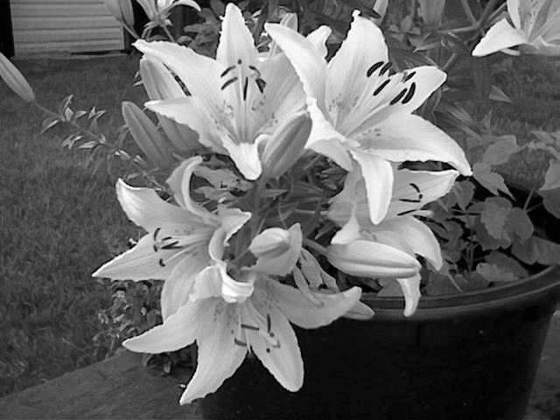
Photograph by Dominick Paul

Book Review
By Donna Rae Dubois
The Church Ladies
by Lisa E. Samson
If you enjoyed Steel Magnolias, you'll love this heartwarming tale of friendship, set in the charming southern town of Mount Oak! The community's churches are competing for members---until tragedy strikes one of their hometown sons. United in prayer, the women of Mount Oak discover the power of love and compassion---and witness a miracle.
When I picked up this book I thought it would be a light read, but I was surprised by the depth of the story and I love the main character, Poppy Fraser. She is so much like me, distracted by circumstances, knowing there is more, but somehow missing it, trying to control and heal broken relationships on her own. It is through the fellowship of ‘sisters’ that she is able to really move forward in her walk and let Jesus heal her wounds and hurts and mold her heart.
This story will make you laugh and cry. It is a story about GRACE. One of the questions Poppy asks the Lord concerning herself, which is lingering in my heart as well, is this; “Have I looked on Your cross frivolously?”
This novel is available in the Portable Library at Life Church! Happy Reading!

Beauty Tips by Gemma Paul

SKIN DEEP

Skin Type - Normal
Characteristics - Few to no breakouts, neither too oily nor too dry, medium pores, smooth and even texture, healthy color
Needs - ph balanced products
Best foundation - cream to powder, tinted moisturizer, liquid, and cream, dual finish, stick, mousse.
Skin Type - Oily
Characteristics - Prone to blackheads, large pores, gets shiny fast, breakout often, wrinkles less, usually highly elastic.
Needs - Oil free products, noncomedogenic products enriched with oil absorbers
Best foundation - cream to powder, liquid (oil free) water based, dual finish, mousse

Recipe Corner
By Kristen Williams

Ladyfinger Cake

Ingredients:
1 Large container of Coolwhip (Largest one)
2 large cans of crushed pineapple (drained)
1 16 oz. container of sour cream
2 4 oz. boxes of instant pistachio or vanilla pudding (keep unmade- just pour in the packs)
3 packages of Ladyfingers

In a bowl, add all ingredients. Mix until combined

In a round 10 – 12” spring form pan line the sides with ladyfingers. Then layer the bottom. Fill half way with pudding mixture. Put another layer of ladyfingers, then pour the remaining mixture on top and you are done. Place in the refrigerator to keep cold. To serve, release from spring form pan. The perfect summertime dessert!

Psalm 23 - EXPLAINED (Author Unknown)

This is an eye opener... Some probably never thought nor looked at this Psalm in this way... even though they have recited it over and over again.

The Lord is my Shepherd; That's Relationship!
I shall not want; That's Supply!
He makes me to lie down in green pastures;
That's Rest!
He leads me beside the still waters; That's Refreshment!
He restores my soul; That's Healing!
He leads me in the paths of righteousness;
That's Guidance!
For His name sake; That's Purpose!
Yea, though I walk through the valley of the shadow of death; That's Testing!
I will fear no evil; That's Protection!
For Thou art with me; That's Faithfulness!
Thy rod and Thy staff they comfort me;
That's Discipline!
Thou prepares a table before me in the presence of my enemies; That's Hope!
Thou anoints my head with oil; That's Consecration!
My cup runs over; That's Abundance!
Surely goodness and mercy shall follow me all the days of my life; That's Blessing!
And I will dwell in the house of the Lord; That's Security!
Forever; That's Eternity!

Have you come to the end of your rope and don’t have anything left to hang on to? Hang on to Jesus. He will never let you down.

American Standard 1917 Edition
JOHN 3:16 “For God so loved the world, that he gave his only begotten Son, that whosoever believeth in him should not perish, but have everlasting life.”
JOHN 3:17 “For God sent not his Son into the world to condemn the world; but that the world through him might be saved.”
JOHN 3:18 “He that believeth on him is not condemned: but he that believeth not is condemned already, because he hath not believed in the name of the only begotten Son of God.”

Accept Jesus into your heart right now. You will never regret it. It is very simple to do. Just say this prayer: “Father, in the name of Jesus, I come to you and I ask you to forgive me of all my sins. I ask Jesus into my heart right now. You said that if I believe in you I would not perish but have eternal life. I believe that and I thank you Jesus for setting me free. I give my life to you Jesus and I say that not only are you my Savior but now you are my Lord. Thank you for loving me. Amen”

Join Life Church on Public Access TV
(Check your local cable company for day and time)
Cox Communications – Channel 15
Serving: Enfield, East Windsor, East Granby, Glastonbury, Granby, Hartland, Manchester, Newington, Rocky Hill, Somers, South Windsor, Suffield, Union, Stafford Springs, Wethersfield, Windsor Locks & Holland, MA

Comcast – Channel 5
Serving: Simsbury & Windsor

Nutmeg TV – Channel 5
Serving: Avon, Berlin, Bristol, Burlington, Canton, Farmington, New Britain & Plainville

Cablevision of Litchfield – Channel 5
Serving: Bantam, Cornwall, Goshen, Litchfield, Morris, Northfield, Oakville, Thomaston, Torrington, Warren & Watertown

Craft Corner by Karen Cobleigh

Friendship Bracelets
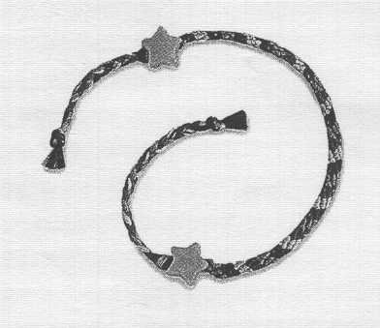

You will need: stranded cotton embroidery thread (floss) in various colors; ruler; scissors, strong sticky tape; and beads in various colors.
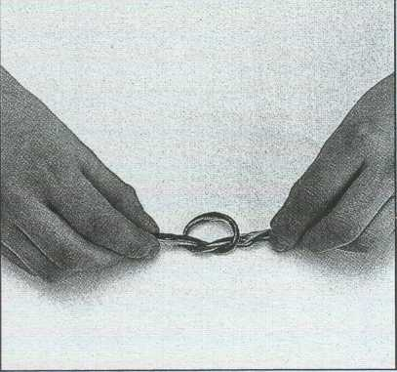
1. Decide on four colors of embroidery thread and cut two strands of each color approximately 16” long. Tie all the strands together in a knot at one of the ends.
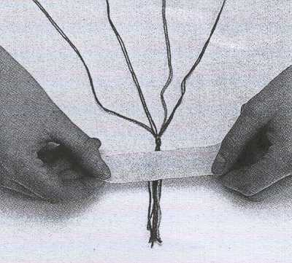
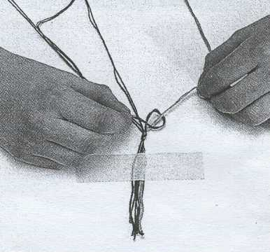
2. Using a strong piece of sticky tape, stick the strands on a flat surface just above the knot. Lay out the threads as shown.

3. Take the first pair of colored threads on the right and knot them over the pair of threads on the left.
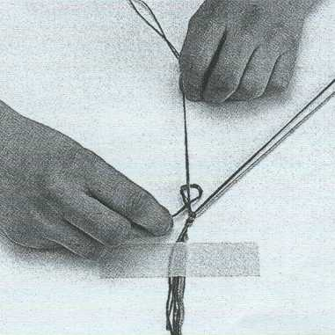
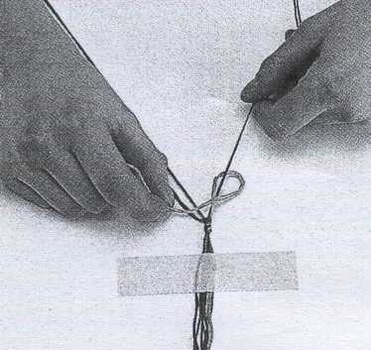
4. Tie another knot and then go on to the next pair of threads and tie two knots. Continue until you get to the end of the row.
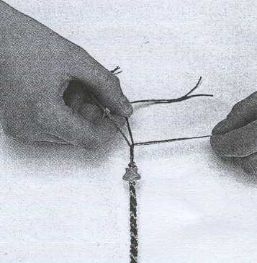
5. Go back to the new thread on the left and continue the same technique, as in step 3. Keep knotting until the bracelet is long enough to fit around the wrist of the person it will be given to.
6. Divide the threads into three sections and plait (braid) them together. Thread on a bead and then tie a knot at the end, to hold the bead in place. Trim off any trailing strands.

evotional by Judy Johnson

“Amazing Grace - how sweet the sound - that saved a wretch like me! I once was lost, but now am found - was blind, but now I see.”
Some interesting things have been happening to me the last few weeks. Wrestling to put the last of four high-backed resin patio chairs in the backseat of my “little” car – all the while thinking how wonderful it would be to have a station wagon or a van – this sweet woman with a little one on her hip came up to me and said, “I have a van and if you can’t fit those in your car, I'll help you get them home.” I was so amazed, it was like God had heard my thoughts and sent me help. A few days later, in the garden store, I was getting some bags of top soil (40 pounds each and sort of wet) – thinking, “Boy! These are heavy; do I really need five? When suddenly this sweet grandfather-type guy came up to me and said, “Let me give you a hand with those, how many did you want?” This time I was a little embarrassed wondering to myself if I had voiced my thoughts out loud. But no, I hadn’t spoken; yet there was my help, a total stranger offering a helping hand. But why me? I don’t think I was looking overly pathetic either day, nor was I displaying frustration or pain. In fact, I was rather enjoying the errands. So, why me? During one of my times of prayer I was thanking God for those helpers, asking Him to bless them and He impressed me with the concept of His grace – His unmerited favor.
I grew up in the Midwest and was a member of the Girl Scout organization; starting as a Brownie in elementary school and stayed an active participant through High School graduation. As a Girl Scout we earned merit badges – symbolic of achievements. But the key to them was that they had to be earned, they weren’t given away freely; there was effort involved. There were specific activities that had to be accomplished within certain timeframes to receive one of those merit badges. But God’s grace – His unmerited favor – is freely given, there’s no work for us to do that will earn it. In fact, it doesn’t come that way. It is simply there if we will yield to it.
“For the law was given by Moses, but grace and truth came by Jesus Christ.” John 1:17
“For by grace are ye saved through faith; and that not of yourselves: it is the gift of God:” Eph 2:8
Continued on page 6

Humor is Contagious

A southern Baptist minister decided that a visual demonstration would add emphasis to his Sunday sermon. Four worms were placed into four separate jars. The first worm was put into a jar of alcohol. The second worm was put into a jar of cigarette smoke. The third worm was put into a jar of chocolate syrup. The fourth worm was put into a jar of good clean soil. At the conclusion of the sermon the minister reported the following results. The first worm in alcohol – dead. The second worm in cigarette smoke – dead. The third worm in chocolate syrup – dead. The fourth worm put in good clean soil – alive. So the minister asked the congregation what you can learn from this demonstration. A little old woman in the back quickly raised her hand and said. “As long as you drink, smoke and eat chocolate you won’t have worms!”
(A Saxon phrase from “Hoot” Schuller)

Attitude is Everything
A 92-year-old, petite, well-poised and proud man, who is fully dressed each morning by eight o’clock, with his hair fashionably coifed and shaved perfectly, even though he is legally blind, moved to a nursing home today. His wife of 70 years recently passed away, making the move necessary. After many hours of waiting patiently in the lobby of the nursing home, he smiled sweetly when told his room was ready. As he maneuvered his walker to the elevator, I provided a visual description of his tiny room, including the eyelet sheets that had been hung on his window. “I love it,” he stated with the enthusiasm of an eight-year-old having just been presented with a new puppy. “Mr. Jones, you haven’t seen the room; just wait.” “That doesn’t have anything to do with it,” he replied. “Happiness is something you decide on ahead of time. Whether I like my room or not doesn’t depend on how the furniture is arranged. It’s how I arrange my mind. I already decided to love it. “It’s a decision I make every morning when I wake up. I have a choice; I can spend the day in bed recounting the difficulty I have with the parts of my body that no longer work, or get out of bed and be thankful for the ones that do. Each day is a gift, and as long as my eyes open, I’ll focus on the new day and all the happy memories I’ve stored away just for this time in my life. Old age is like a bank account. You withdraw from what you’ve put in. So, my advice to you would be to deposit a lot of happiness in the bank account of memories!
Remember the six simple rules to be happy:
1. Free your heart from hatred.
2. Free your mind from worries.
3. Live simply.
4. Give more.
5. Expect less.
6. Trust God with all the rest.

Devotional Continued from page 5
“But unto every one of us is given grace according to the measure of the gift of Christ.” Eph 4:7
In the garden store, when the man came up and gently lifted the heavy bag from my arms, I could have held tighter to that bag and refused his help. But what a relief it was to allow that weight to be so effortlessly lifted – because I yielded to the offer of help. How often does God come along, sending us relief for our struggles or burdens, and we stubbornly hold fast – thinking to ourselves, “that’s mine! Don’t take that away, that’s part of me, that’s my struggle to overcome.” When all along God is offering us His grace and all we need to do is yield.
What a beautiful God we serve, and how kind and gentle a teacher He is.
"But grow in grace, and in the knowledge of our Lord and Savior Jesus Christ. To Him be glory both now and for ever. Amen." 2 Peter 3:18
“And he said unto me, My grace is sufficient for thee: for my strength is made perfect in weakness.” 2 Corinthians 12:9

Where Do I Find It In The Bible?
The Life of Jesus
Birth of Jesus | Matthew 1:18 - 2:15; Luke 2:1 – 20
Jesus is Named and Presented in the Temple | Luke 2:21 – 40
The Young Jesus in the Temple | Luke 2: 41 - 52
Baptism of Jesus | Matthew 3:13 – 17; Mark 1:9 – 11; Luke 3:21, 22
Temptation of Jesus | Matthew 4:1 – 11; Mark 1:12, 13; Luke 4:1 – 13
Jesus Calls His First Disciples | Matthew 4:18 – 22; Mark 1:16 – 20
Jesus Chooses Twelve Apostles | Matthew 10:1 – 4; Mark 3:13 – 19; Luke 6:12 – 16
Transfiguration of Jesus | Matthew 17:1 – 13; Mark 9:2 – 13; Luke 9:28 – 36

A Strong Woman
(Author Unknown)
A strong woman works out every day to keep her body in shape…but a woman of strength kneels in prayer to keep her soul in shape.

A strong woman isn’t afraid of anything…but a woman of strength shows courage in the midst of her fear.

A strong woman won’t let anyone get the best of her…but a woman of strength gives the best of herself to everyone.

A strong woman makes mistakes and avoids the same in the future…a woman of strength realizes life’s mistakes can also be God’s blessings and capitalizes on them.

A strong woman walks with a sure foot…but a woman of strength knows God will catch her when she falls.

A strong woman wears the look of confidence on her face…but a woman of strength wears grace.
A strong woman has faith that she is strong enough for the journey…but a woman of strength has faith that it is in the journey that she will become strong.

From the Heart of…Continued from page 1
My heart has become so tender towards the many hurting people in our world today. Joel 3:14 says, “Multitudes, multitudes in the valley of decision: for the day of the LORD is near in the valley of decision.” There are people in our lives that are searching. Some don’t even realize what whey are searching for. They go from one activity to another, they run from one thing to another but nothing quite satisfies. They become disillusioned, bored with it and then off they go again, searching. Some actually do know what they are searching for, but can’t find it. They are desperately trying to find their way back to God. (Song of Solomon 3:1-2, Is 55:6-7) Ezekiel 34:16 says, “I will seek that which was lost, and bring again that which was driven away, and will bind up that which was broken, and will strengthen that which was sick:”. They need to be pointed to Jesus, the shepherd who left the ninety and nine and went after the one lost sheep (Matt 18:11-13). They are the lost, looking to be found. They need someone to light the way. We are called to be the light of the world. We are to be that city on a hill (Matt 5:14-16), that place that the lost of our world can come to so that they may be found! Luke 15:5-6 ends with
“. . . Rejoice with me; for I have found my sheep which was lost.” Luke 19:10 says, “For the Son of man is come to seek and to save that which was lost.”
So, next time someone asks me if we have a “Lost and Found” at Life Church I want to be able to say, “Yes, we do, we surely do.” (2 Peter 3:14) By the way, if the needle is yours let me know, I still have it!
Judy
“But go rather to the lost sheep of the house of Israel. And as ye go, preach, saying, ‘The kingdom of heaven is at hand. Heal the sick, cleanse the lepers, raise the dead, cast out devils: freely ye have received, freely give’.”
Matt 10:6-8
Prayer for the Pastor

Hedging in the Pastor

Read Ephesians 6:10 – 18
Meditate the Greatness of God in behalf of our pastor and his family: Romans 8:28, 31, 37 and I Peter 3:12
Expose the wiles of the devil:
Ephesians 6:11 – 12
Claim scriptural promises for their overall protection: Isaiah 54:14 – 17; Psalm 34:7; Psalm 91, Luke 10:19 and 2 Corinthians 10:3 – 4
Petition the Father to grant them a discerning spirit:
2 Corinthians 11:14 and 1 John 4:1

f you have any comments, questions, or additions to this newsletter, contact the Editor.
Jean Redekas
JRedekas@comcast.net
860-670-3194

“Before the mountains were brought forth,
or ever thou hadst formed the earth and the world,
even from everlasting to everlasting, thou art God.”
Psalms 90:2



Photograph by Jacqueline Redekas
Picture by Jean Redekas

Life Church
23 Griffin Road
Granby, CT 06035
860-653-3308
www.GranbyLifeChurch.com
To:

Printed at Olivieri Quickprint Center, 17 Hartford Avenue, Granby, Connecticut 06035, (860) 653-6928, Fax (860) 653-3768, olivieriquickprint.com

